Entering Time and Leave on Self-Service Dashboard for
Bi-Weekly (Non-Exempt) Employees
Accessing Time/Absence Entry
- Log in to the MyUW portal at http://www.wisc.edu. Click on MyUW dropdown on the menu at the top of the screen and then go to MyUW Home.
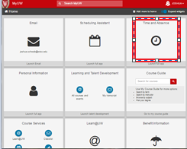
- Enter your UW NetID and Password. Then click the Login Button.
- Click on Time and Absence.
- You may be required to enter a one-time password.
5. Select timesheet to enter your time and absences.
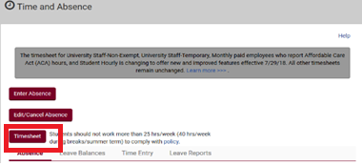
Reporting Time
1. Select the correct time period. If you have a default schedule assignment, the total scheduled hours for the period being viewed will display. If you don’t have a default schedule (most employees don’t), you will need to enter your time on the timesheet.
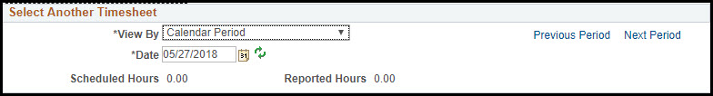
The "Shift In" and "Shift Out" fields are used to record the start and finish of a work shift.

The second "Break Out" and "Break In" fields are only used to record an unpaid break (i.e. lunch) within the work shift.

After you enter your time, and if you have no absences to enter, click the “submit” button at the bottom of the screen. If you have absences to enter, review the instruction on entering absences before submitting the final timesheet.
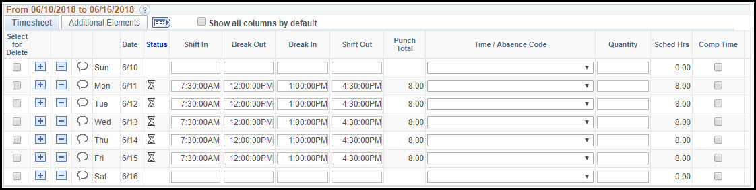
When you enter In and Out punch times in the timesheet, the reported time will be rounded to quarter hours in payable time. Please refer to TL - Rounding of Reported Time to Payable Time in HRS for more information.
Adding a Full Day Absence: 1. Select the appropriate Time/Absence Code from the dropdown on the row associated with the date of the absence.
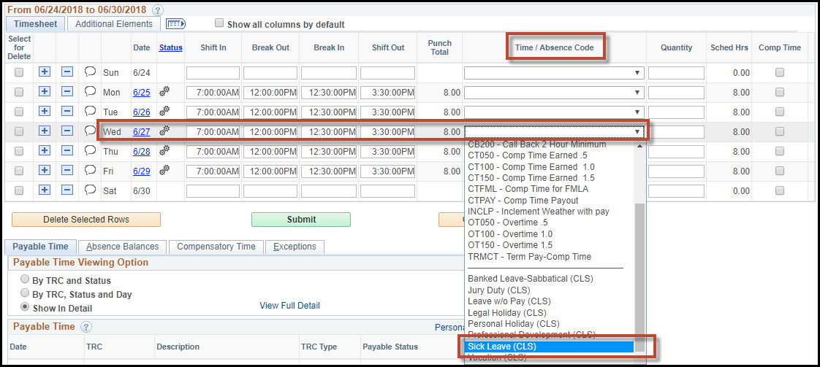
2. If you have a default schedule, the punch fields/times disappear and the quantity will automatically populate with the number of scheduled hours. If you do not have a default schedule, enter the number of hours associated with the absence taken.
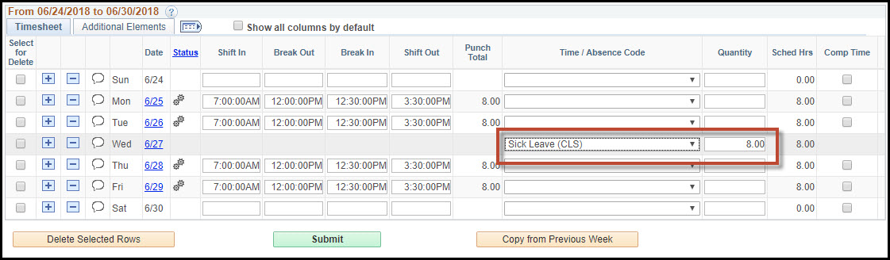
3. Click Submit

Adding a Partial Day Absence Take:
1. Add a row to the day associated with the partial-day absence by clicking the (+) button.
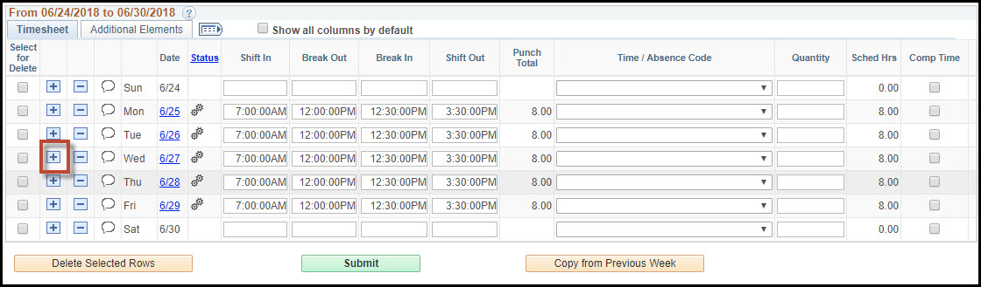

2. On the new row select the type of absence take from the Time/Absence Code drop down.
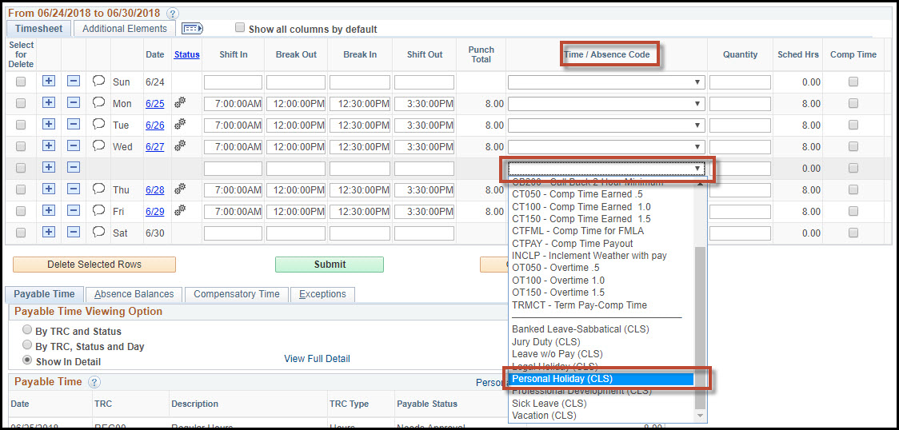
3. Enter the appropriate number of hours associated with the absence take in the quantity field.
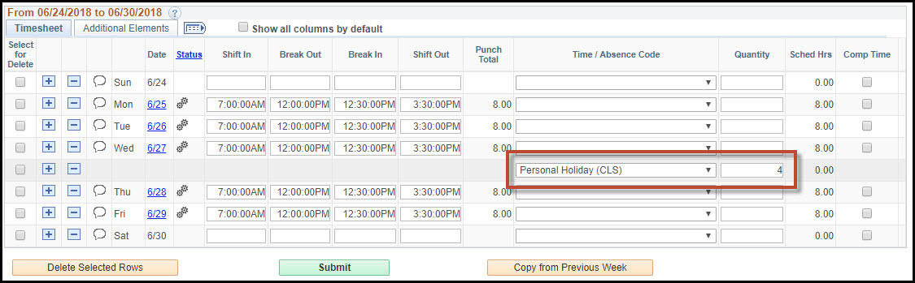

4. If you have already submitted punch time or has a default schedule assignment, update the punch times to reflect hours worked accordingly.
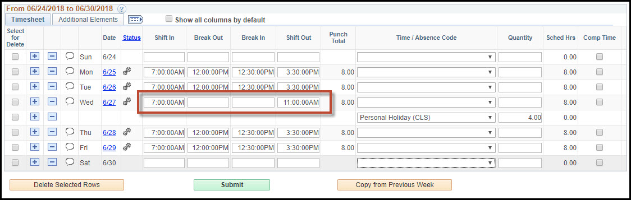
5. Click Submit.
Updating an Absence Type or Quantity
Updates made to absence types or quantity of hours can be made from the integrated timesheet. These changes will automatically be updated on the UWS Absence and Absence Event pages.
1. To update the absence type, choose the appropriate take from the Time/Absence Code dropdown.
2. To update the absence quantity, enter the appropriate number of hours associated with the absence take in the Quantity field.

Status Icons
Status icons on the timesheet indicate the stage of processing reported or payable time is in. Access the legend of status icons by hovering over the "Status" link. You may also hover over the icon itself to view the description.

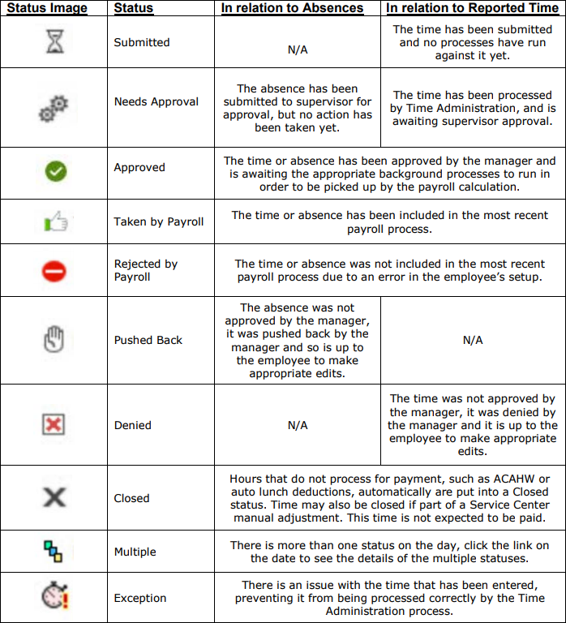

Earning Comp Time:
1. To earn comp time in lieu of overtime, put a checkmark in one of the boxes in the Comp Time column within the week. Only one box within the week needs to be checked in order for overtime earnings to calculate as comp time.
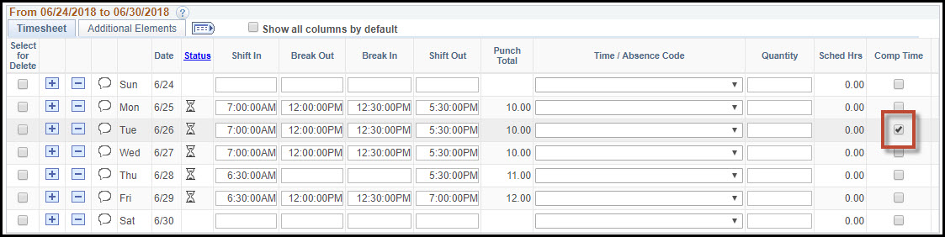
2. Click Submit.
Using Comp Time:
1. To use comp time hours, select the CTUSE time reporting code from the Time/Absence code dropdown and enter the quantity of hours to be used.
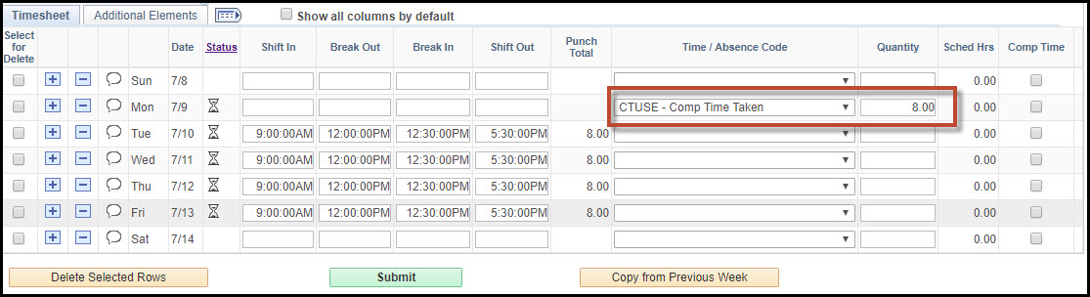
2. Click Submit.

Reviewing Absence Balances:
You can review your Absence Balances by clicking the "Absence Balances" tab in the summary
section underneath the punch timesheet. Note that the current balances do not reflect absence that have not yet been processed.
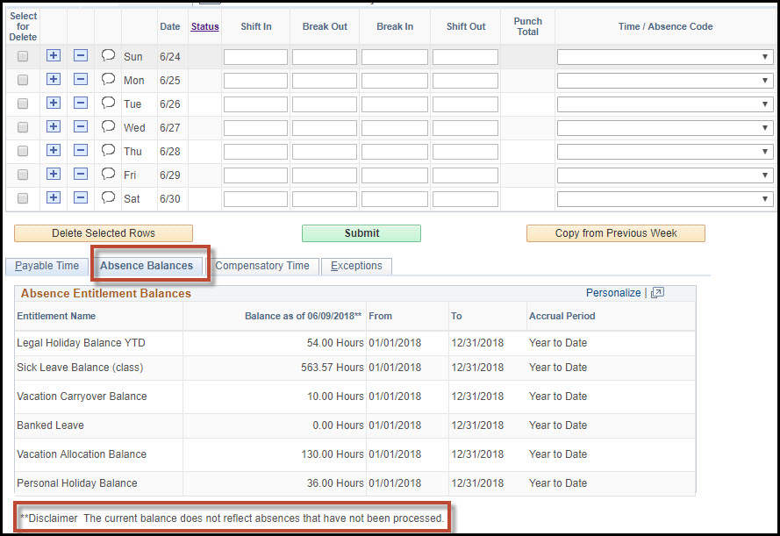

SUPPLEMENTAL RESOURCES
There are several KBs that provide online step by step instructions.
Employees can also use the link below to access the HRS KnowledgeBase.
https://kb.wisc.edu/hrs/
KB NAME | LINK
Payroll Calendar | Payroll Calendar Link
Punch Hourly Integrated Timesheet | https://kb.wisc.edu/hrs/page.php?id=82812
Rounding Reporting Time to Payable Time in HRS | https://kb.wisc.edu/hrs/page.php?id=48921
Using Timesheet View By | https://kb.wisc.edu/hrs/page.php?id=16421
Time Reporting Codes | https://kb.wisc.edu/hrs/page.php?id=16544
Time and Absence Help | https://uwservice.wisconsin.edu/help/time-absence/
Time and Absence Video | https://uwservice.wisconsin.edu/docs/pd/mss-dashboard/index.html

The following directions are only for those who need to edit time on a default schedule timesheet:
Overriding Default Scheduled Hours

If you did not work a scheduled shift, it is necessary to clear the hours from that day in the timesheet. To clear the hours from a scheduled day:
1. Click the delete (-) button on the row for which you need to remove the scheduled hours. You may also check the "Select for Delete" box(es) for the row(s) you need to remove scheduled hours and then click "Delete Selected Rows".
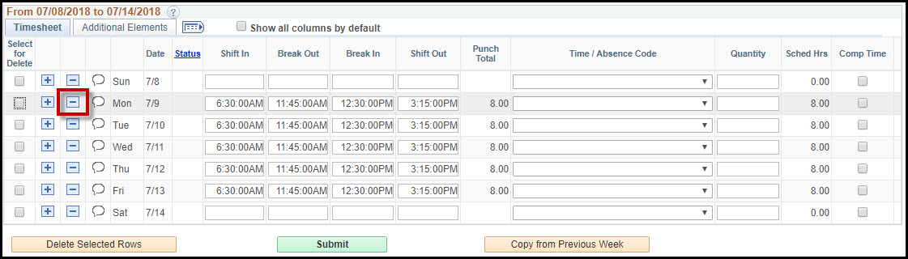
OR
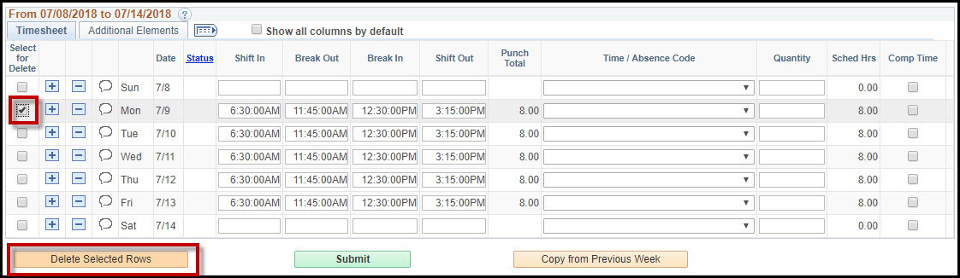
2. To override the scheduled hours, enter a "0" in the quantity column. Click Submit.
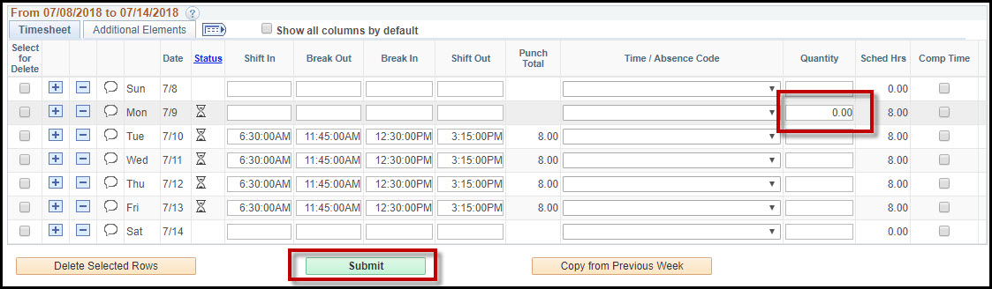
Editing Default Schedule Punch Time
1. If you work different hours than scheduled, including taking lunch at a different time, the punch times should be changed in the timesheet to reflect what was actually worked. It is best practice to delete the entire row of scheduled hours prior to making punch time changes. Delete the row by either clicking the (-) icon or checking the "Select for Delete" checkbox and then clicking "Delete Selected Rows".
2. Enter the new punch times on the appropriate row.
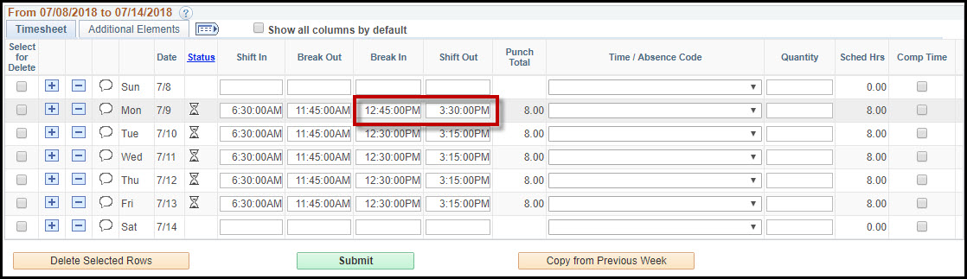

Updated on: 07/24/19

